End of Program Project

420-ENW-MT

**“JobHunt”**



**Submitted by**

|  |  |  |
| --- | --- | --- |
| **S.No** | **Student Name** | **Student ID** |
| 1 | Mayurkumar Patel | 2091270 |
| 2 | Meet Patel | 2091085 |
| 3 | Abhishek Kathuria | 2091103 |
| 4 | Shiva Praneeth Pabathi | 2091461 |
| 5 | Sruthi Podupati | 1995568 |

**Under the Guidance of**

Prof.Reza Madabadi

Prof.Sakshi Sharma

Prof.Sliviya Paskelava

# **Table Of Contents**

**Description** **4**

**User Stories** **5**

User 5

Admin 10

**User Backlog Table** **12**

User 12

Admin **Error! Bookmark not defined.**3

**Functional Requirements** **Error! Bookmark not defined.**4

User 144

Admin 155

**Non Functional Requirements** **Error! Bookmark not defined.6**

**Poker Planning**18**8**

**Release Plan 1**26**6**

**Release Plan 2** **Error! Bookmark not defined.7**

**Release Plan 3**28**8**

**U****ML Diagrams 29**

**Sequence Diagrams 29**

User Sequence Diagram 29

Admin Sequence Diagram 30

**Activity Diagrams 31**

User Activity Diagram 31

Admin Activity Diagram 32

**Usecase Diagram 33**

**Class Diagram 34**

**E-R Diagram 35**

**Fully Dressed Use Cases 36**

User 36

Admin 39

**Application Screens 41**

User Screens 41

Admin Screens 49

**Prototype Flow 53**

User Screen Flow 53

Admin Screen Flow 54

**Test Cases 55**

User 55

Admin 64

**Bibliography 66**

# 

# 

# 

# 

# 

# 

# 

# 

# 

# **Description**

Since the initiation of the 21st century, people are becoming more aware about the need for education and the students are more serious about getting higher education. Besides this, the MNC’s are growing with a surprising upward trend. Therefore, our team has decided to implement a mobile application to help the candidates , finding better jobs according to their education level as well as the industries which are looking for highly skilled employees to improve their product quality or services. This Mobile application will help employees finding career options worldwide and employers to hire people from any corner of the world and vice versa. Apart from the hiring process, people will also be able to share the job option with others, as a result, it will give a platform to small scale companies to grow. Overall, it will bring a revolutionary change to the current job market.

# 

# 

# 

# 

# 

# 

# **User Stories**

## **User:**

|  |  |
| --- | --- |
| ID | MAD01 |
| User Story | As a user I want splash screen |
| User Story Points | 2 |
| Priority | Low |

|  |  |
| --- | --- |
| ID | MAD02 |
| User Story | As a new user I want to sign up |
| User Story Points | 2 |
| Priority | High |

|  |  |
| --- | --- |
| ID | MAD03 |
| User Story | As a user I want to login |
| User Story Points | 3 |
| Priority | High |

|  |  |
| --- | --- |
| ID | MAD04 |
| User Story | As a user I want to have forgot password |
| User Story Points | 3 |
| Priority | Low |

|  |  |
| --- | --- |
| ID | MAD05 |
| User Story | As a user I want search bar |
| User Story Points | 5 |
| Priority | High |

|  |  |
| --- | --- |
| ID | MAD06 |
| User Story | As a user I want list of recently added jobs |
| User Story Points | 3 |
| Priority | Medium |

|  |  |
| --- | --- |
| ID | MAD07 |
| User Story | As a user I want to add new job post |
| User Story Points | 5 |
| Priority | Low |

|  |  |
| --- | --- |
| ID | MAD08 |
| User Story | As a user I want job details |
| User Story Points | 3 |
| Priority | High |

|  |  |
| --- | --- |
| ID | MAD09 |
| User Story | As a user I want the list of saved jobs |
| User Story Points | 5 |
| Priority | High |

|  |  |
| --- | --- |
| ID | MAD10 |
| User Story | As a user I want to update my details |
| User Story Points | 5 |
| Priority | Low |

|  |  |
| --- | --- |
| ID | MAD11 |
| User Story | As a user I want to search jobs according to location |
| User Story Points | 8 |
| Priority | Medium |

|  |  |
| --- | --- |
| ID | MAD12 |
| User Story | As a user I want to search jobs according to company name |
| User Story Points | 8 |
| Priority | Medium |

|  |  |
| --- | --- |
| ID | MAD13 |
| User Story | As a user I want to search jobs according to industry |
| User Story Points | 8 |
| Priority | Medium |

|  |  |
| --- | --- |
| ID | MAD14 |
| User Story | As a user I want to search jobs according to employment type |
| User Story Points | 8 |
| Priority | Low |

|  |  |
| --- | --- |
| ID | MAD15 |
| User Story | As a user I want to apply for a job. |
| User Story Points | 8 |
| Priority | High |

|  |  |
| --- | --- |
| ID | MAD16 |
| User Story | As a user I want to know the list of applicants who applied for a posted job. |
| User Story Points | 3 |
| Priority | High |

|  |  |
| --- | --- |
| ID | MAD17 |
| User Story | As a user I want to know the details of applicants who applied for a posted job. |
| User Story Points | 3 |
| Priority | Medium |

|  |  |
| --- | --- |
| ID | MAD18 |
| User Story | As a user I want to accept or decline the applicants who applied for a posted job. |
| User Story Points | 3 |
| Priority | Low |

## **Admin:**

|  |  |
| --- | --- |
| ID | MAD01 |
| User Story | As an admin I want to login |
| User Story Points | 5 |
| Priority | High |

|  |  |
| --- | --- |
| ID | MAD02 |
| User Story | As an admin I want to see job post list |
| User Story Points | 2 |
| Priority | High |

|  |  |
| --- | --- |
| ID | MAD03 |
| User Story | As an admin I want to see user’s list |
| User Story Points | 3 |
| Priority | Medium |

|  |  |
| --- | --- |
| ID | MAD04 |
| User Story | As an admin I can verify every user’s post before posted publicly |
| User Story Points | 5 |
| Priority | Low |

|  |  |
| --- | --- |
| ID | MAD05 |
| User Story | As an admin I can delete any user’s post |
| User Story Points | 3 |
| Priority | Medium |

# **Additional User Stories**

|  |  |
| --- | --- |
| ID | MAD19 |
| User Story | As a user I want to know the status of the job post. |
| User Story Points | 3 |
| Priority | Medium |

|  |  |
| --- | --- |
| ID | MAD20 |
| User Story | As a user I want to know the status of the applied job. |
| User Story Points | 3 |
| Priority | Medium |

# 

# **User Backlog Table**

## **User:**

|  |  |  |  |
| --- | --- | --- | --- |
| **ID** | **User Story** | **User Story Points** | **Priority** |
| MAD01 | As a user I want splash screen | 2 | Low |
| MAD02 | As a new user I want sign up | 2 | High |
| MAD03 | As a user I want to login | 3 | High |
| MAD04 | As a user I want to have forgot password | 3 | Low |
| MAD05 | As a user I want search bar | 5 | High |
| MAD06 | As a user I want list of recently added jobs | 3 | Medium |
| MAD07 | As a user I want to add new job post | 5 | Low |
| MAD08 | As a user I want job details | 3 | High |
| MAD09 | As a user I want the list of saved jobs | 5 | High |
| MAD10 | As a user I want to update my details | 5 | Low |
| MAD11 | As a user I want to search jobs according to location | 8 | Medium |
| MAD12 | As a user I want to search jobs according to company name | 8 | Medium |
| MAD13 | As a user I want to search jobs according to industry | 8 | Medium |
| MAD14 | As a user I want to search jobs according to employment type | 8 | Low |
| MAD15 | As a User I want to apply for a job. | 8 | High |
| MAD16 | As a user I want to know the list of applicants who applied for a posted job. | 3 | High |
| MAD17 | As a user I want to know the details of applicants who applied for a posted job. | 3 | Medium |
| MAD18 | As a user I want to accept or decline the applicants who applied for a posted job. | 3 | Low |

## **Admin:**

|  |  |  |  |
| --- | --- | --- | --- |
| **ID** | **User Story** | **User Story Points** | **Priority** |
| MAD01 | As an admin I want to login | 5 | High |
| MAD02 | As an admin I want to see job post list | 2 | High |
| MAD03 | As an admin I want to see user’s list | 3 | Medium |
| MAD04 | As an admin I can verify every user’s post before posted publicly | 5 | Low |
| MAD05 | As an admin I can delete any user’s post | 3 | Medium |
|  | TOTAL USER POINTS | 94/3=31 |  |

# 

# 

# **Functional Requirements**

## **User:**

|  |  |  |  |
| --- | --- | --- | --- |
| **Requirement ID** | **Requirement Statement** | **Must/Want** | **Description** |
| FR001 | Registration | Must | The user should be able to register. |
| FR002 | User login | Must | The user should be able to login |
| FR003 | Forgot password | Must | The user should be able to reset password in case of( forgot password) |
| FR004 | View details | Want | The user should be able to view his/her details. |
| FR005 | Update profile | Want | The user should be able to update his/her profile |
| FR006 | Apply job | Must | The user should be able to apply for the job if there is any vacancy available. |
| FR007 | View available jobs | Must | The user should be able to view all the available jobs |
| FR008 | View applied jobs | Want | The user should be able to view all the job he/she has applied for. |
| FR009 | Apply multiple jobs | Want | The user should be able to apply for multiple jobs. |
| FR010 | Search jobs | Want | The user should be able to search for jobs based on company, location and type. |
| FR011 | Data adding job post | Must | The user should be able to post jobs with detailed job descriptions. |

## **Admin:**

|  |  |  |  |
| --- | --- | --- | --- |
| **Requirement ID** | **Requirement Statement** | **Must/Want** | **Description** |
| FR012 | Admin login | Must | The admin should be able to login. |
| FR013 | Data viewing job list | Must | The admin should be able to view all the jobs. |
| FR014 | Verification of data received | Must | The admin should be able to verify a job posted by the user before being posted publicly. |
| FR015 | Database data deletion | Must | The admin should be able to delete any user’s post. |
| FR016 | Data viewing user list | Must | The admin should be able to view the user's list. |

# 

# 

# **Non Functional Requirements**

|  |  |  |
| --- | --- | --- |
| **Requirement ID** | **Requirement Statement** | **Description** |
| NFR001 | Performance | The application is developed the way , it will be measurable that it can be opened in 3 seconds when  the user clicks it. |
| NFR002 | Scalability | The application is efficiently scaling i.e Choosing firestore and designing flexible schema we’re able to handle 1000 users. |
| NFR003 | Usability | The application should be user friendly. I.e. the user can understand the use of every functionalities as we are implementing functionalities such as Navigation Menu and Date picker. |
| NFR004 | Security | The information of the user is kept secure by using firebaseauth for authenticating the user. |
| NFR005 | Serviceability | The response time for any event should be less than 3 seconds. |
| NFR006 | Consistency | The application flow should be consistent throughout the execution.(flow from one screen to other screen) |
| NFR007 | Capacity | The application size should be maximum of 22Mbs so that it will not occupy more space on the devices. And the data will be stored in a database rather than locally. |
| NFR008 | Compatibility | This app requires a minimum android version of Lollipop version 5.1.1 and 2 GB RAM. |
| NFR009 | Localization | This app meets local specifics. As we are going to implement functionality for french translation. |
| NFR010 | Recoverability | In the event of the user cancelling or quitting the process of “Forgot Password” any changes made by the user will be reversed.(Firebase Authentication) |

# **Poker Planning**

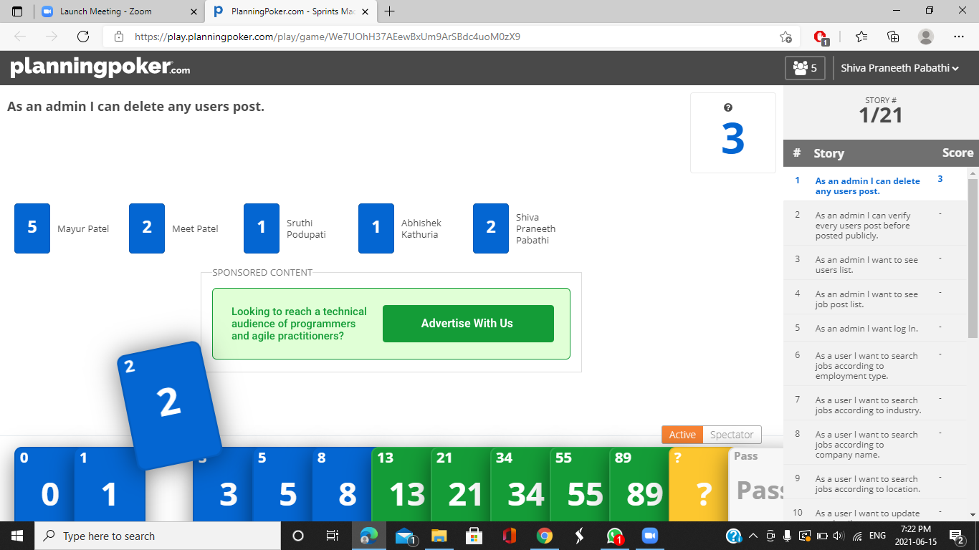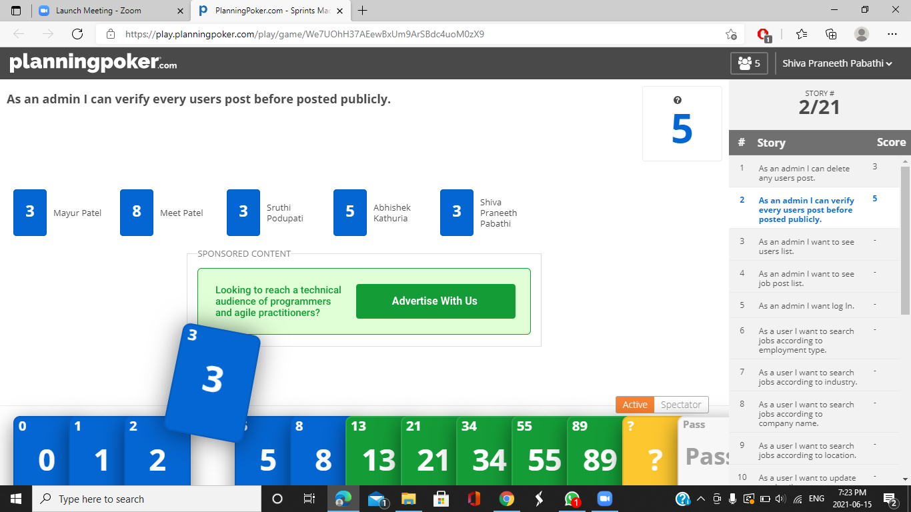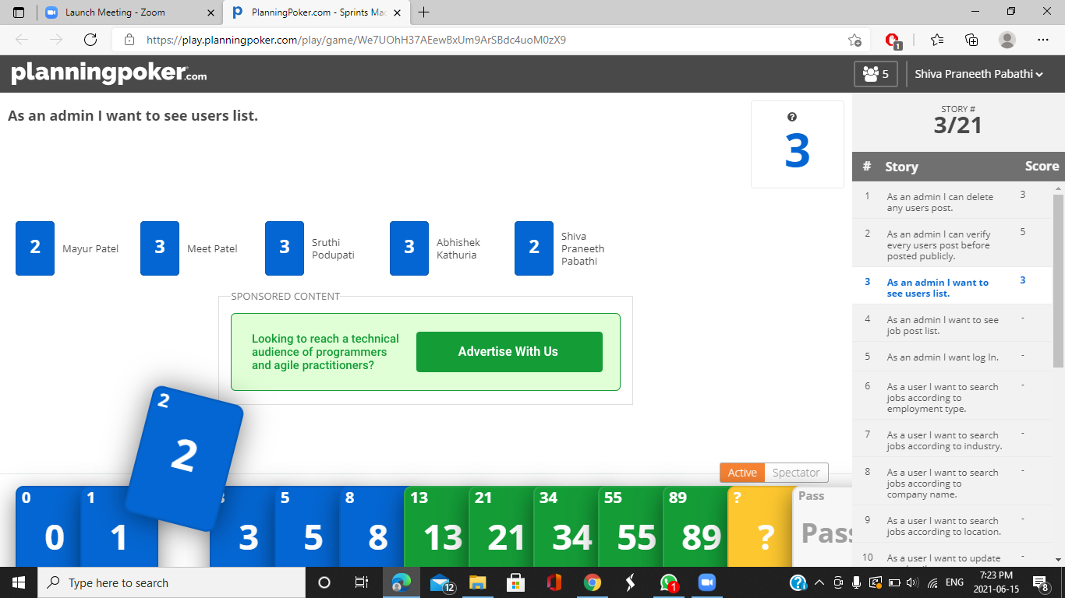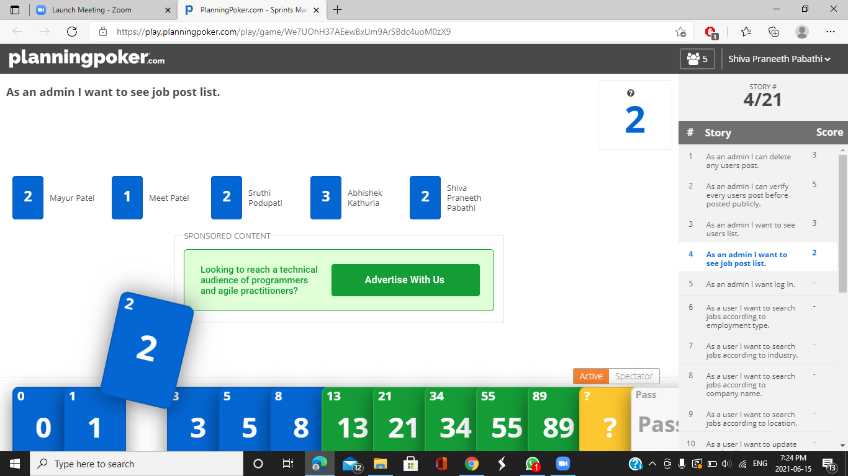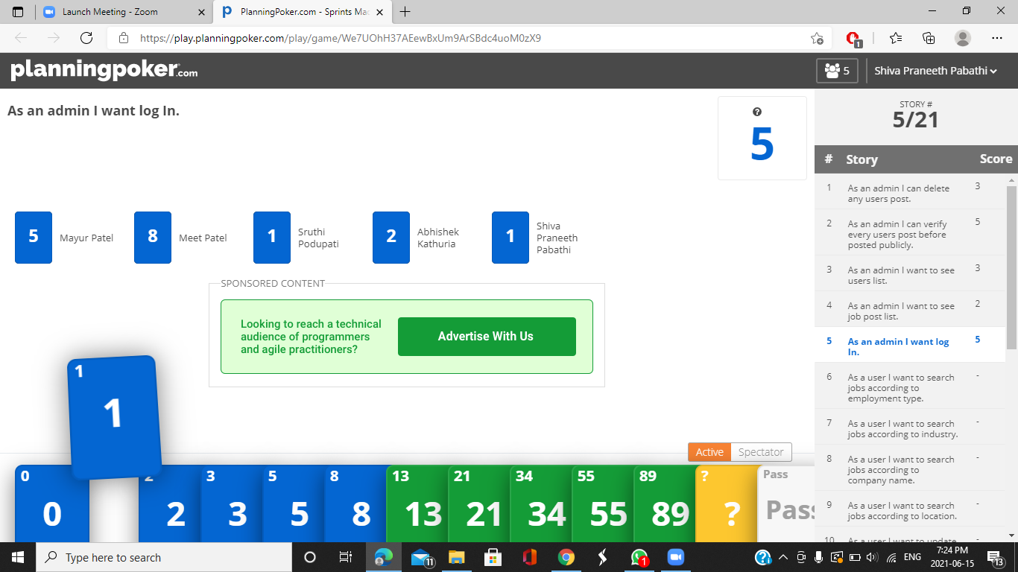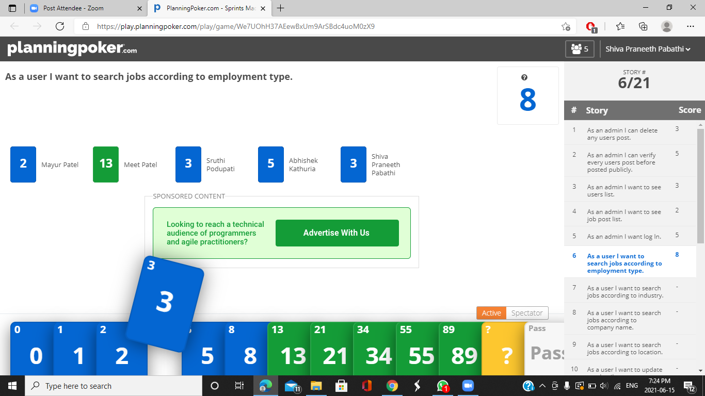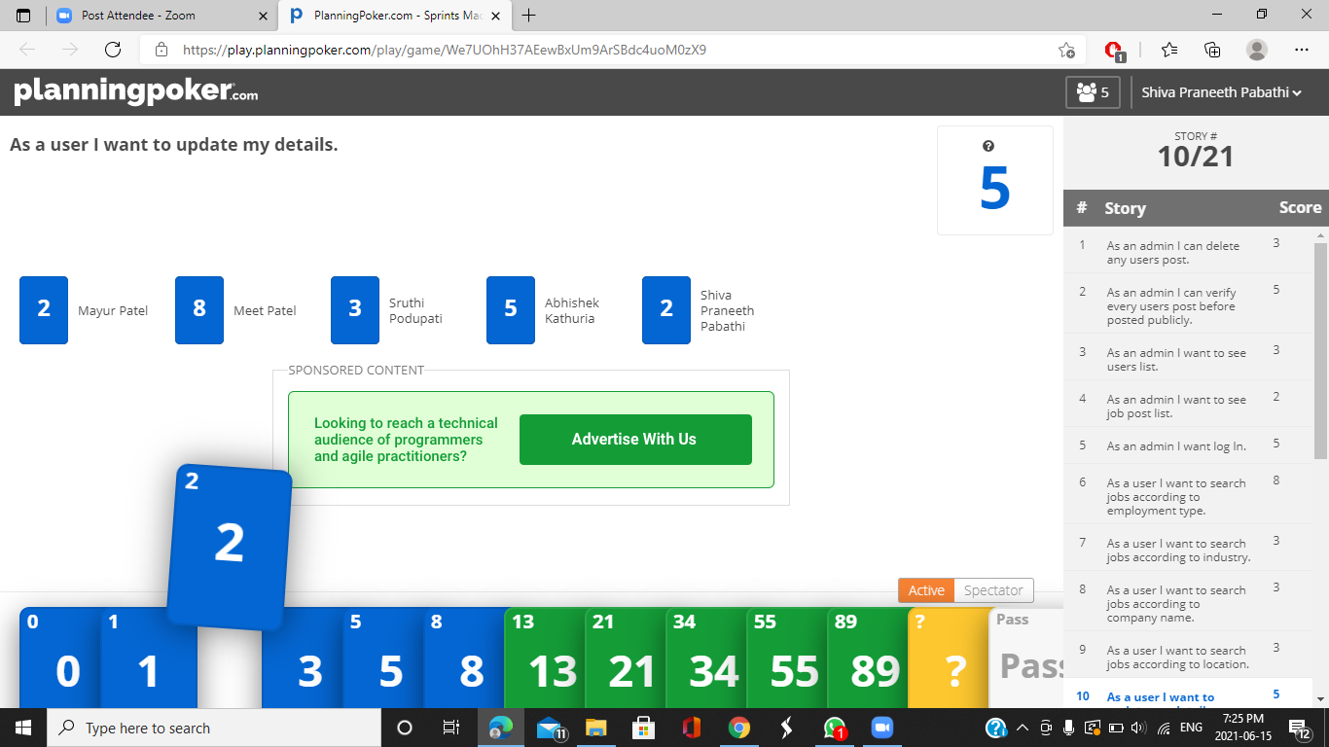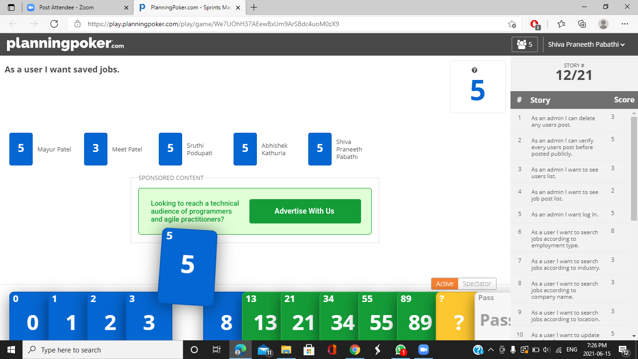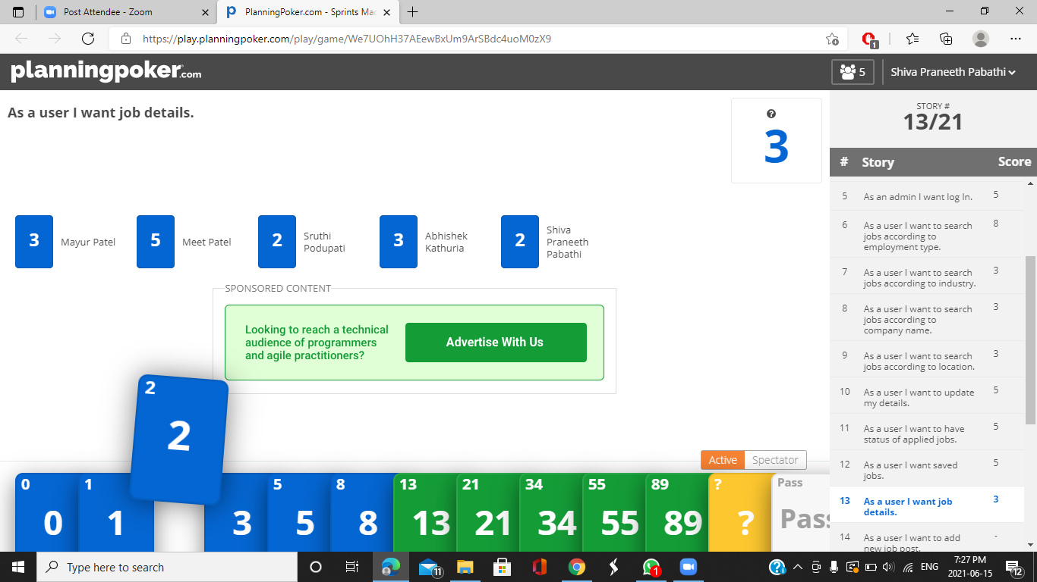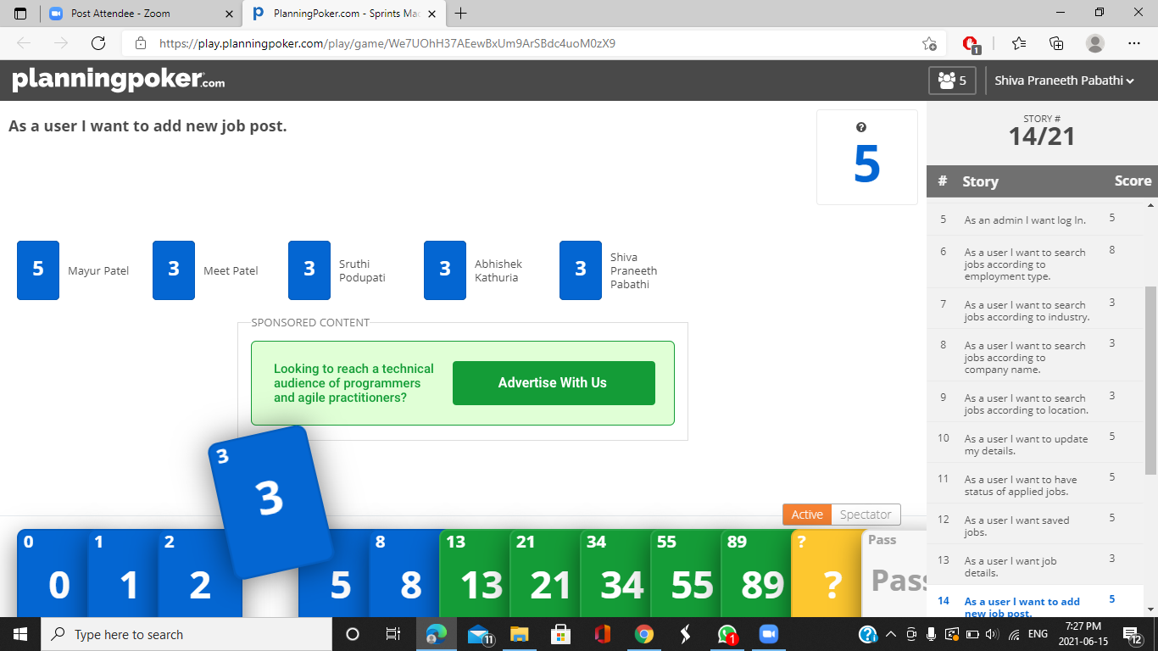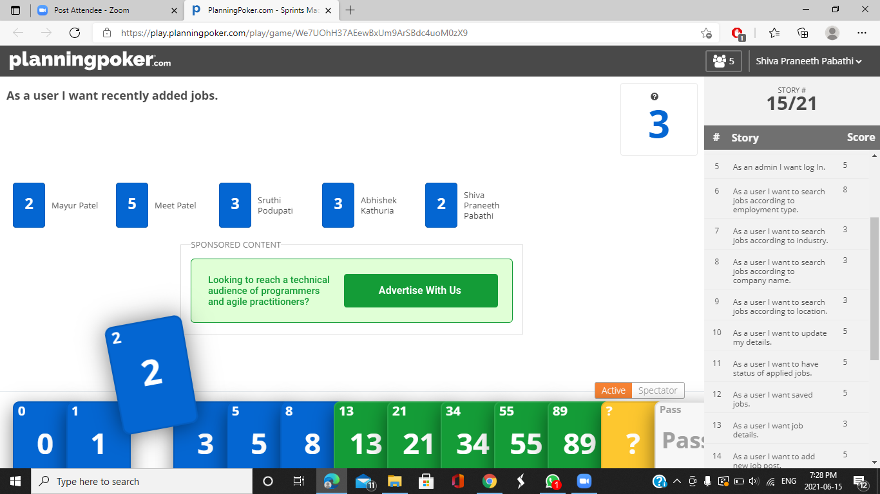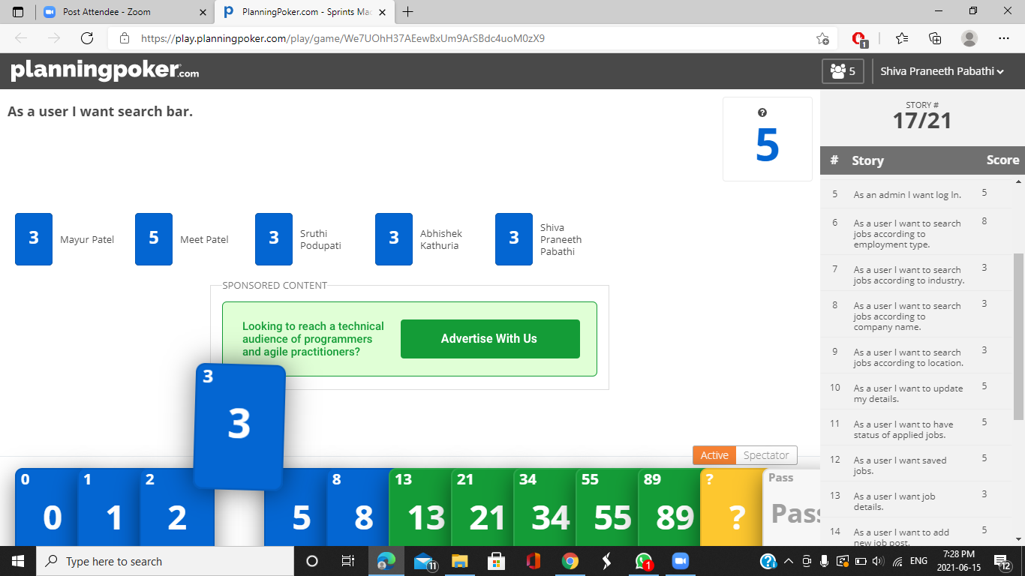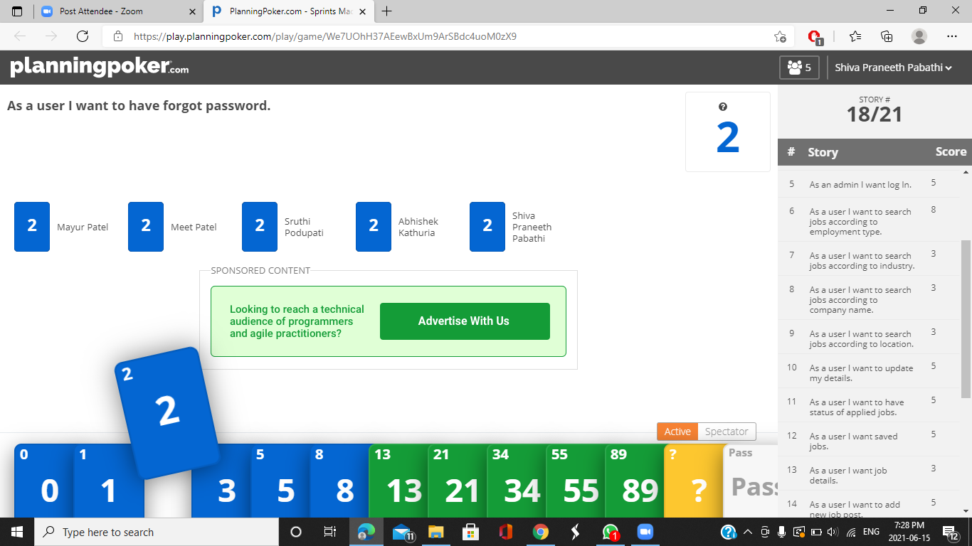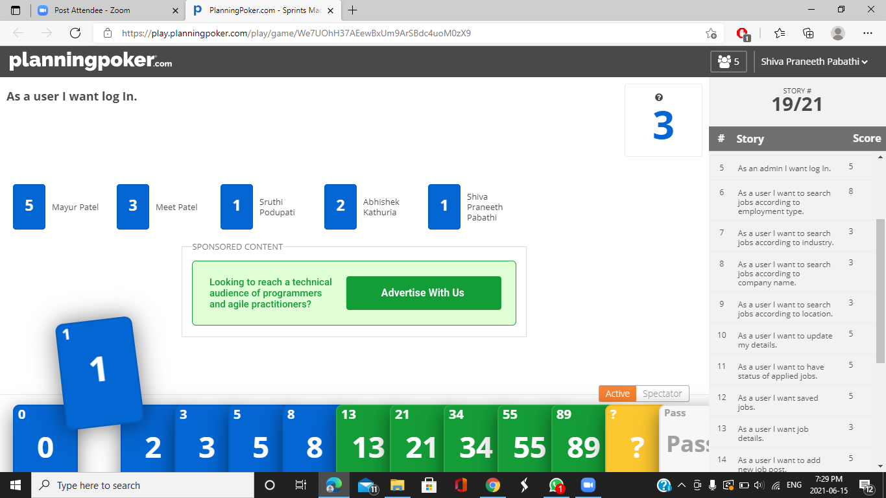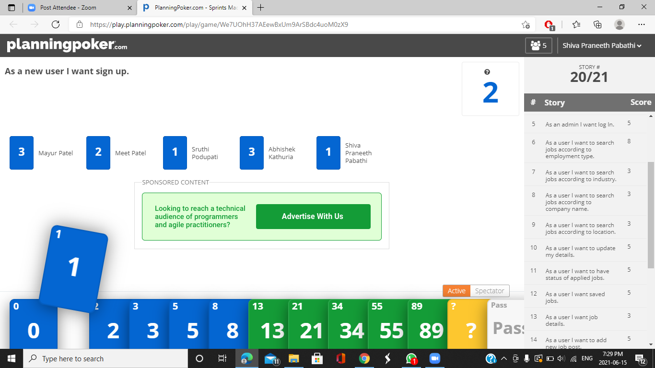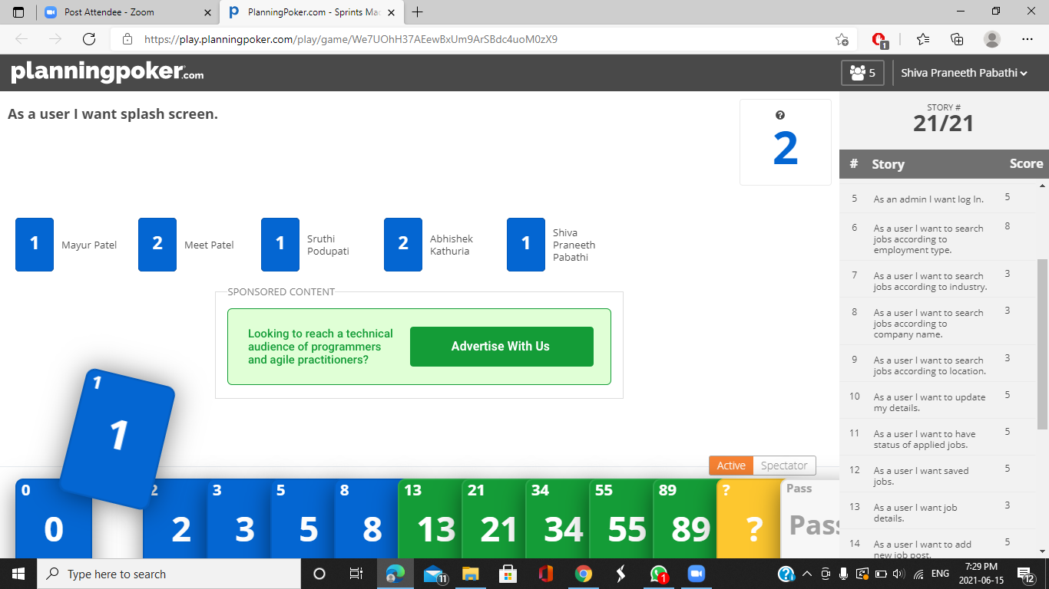

# **Release Plan 1**

|  |  |  |  |
| --- | --- | --- | --- |
| **ID** | **User Story** | **User Story Points** | **Priority** |
| MAD02 | As a new user I want sign up | 2 | High |
| MAD03 | As a user I want to login | 3 | High |
| MAD05 | As a user I want search bar | 5 | High |
| MAD08 | As a user I want job details | 3 | High |
| MAD09 | As a user I want the list of saved jobs | 5 | High |
| MAD15 | As a user I want to apply for a job | 8 | High |
| MAD16 | As a user I want to know the list of applicants who applied for a posted job. | 3 | High |
| MAD01-A | As an admin I want to login | 5 | High |
|  | TOTAL USER POINTS | 34 |  |

# **Release Plan 2**

|  |  |  |  |
| --- | --- | --- | --- |
| **ID** | **User Story** | **User Story Points** | **Priority** |
| MAD02-A | As an admin I want to see job post list | 2 | High |
| MAD11 | As a user I want to search jobs according to location | 8 | Medium |
| MAD12 | As a user I want to search jobs according to company name | 8 | Medium |
| MAD13 | As a user I want to search jobs according to industry | 8 | Medium |
| MAD06 | As a user I want list of recently added jobs | 3 | Medium |
| MAD17 | As a user I want to know the details of applicants who applied for a posted job. | 3 | Medium |
| MAD03-A | As an admin I want to see user’s list | 3 | Medium |
|  | TOTAL USER POINTS | 35 |  |

# 

# **Release Plan 3**

|  |  |  |  |
| --- | --- | --- | --- |
| **ID** | **User Story** | **User Story Points** | **Priority** |
| MAD05-A | As an admin I can delete any user’s post | 3 | Medium |
| MAD01 | As a user I want splash screen | 2 | Low |
| MAD04 | As a user I want to have forgot password | 3 | Low |
| MAD07 | As a user I want to add new job post | 5 | Low |
| MAD10 | As a user I want to update my details | 5 | Low |
| MAD14 | As a user I want to search jobs according to employment type | 8 | Low |
| MAD18 | As a user I want to accept or decline the applicants who applied for a posted job. | 3 | Low |
| MAD04-A | As an admin I can verify every user’s post before posted publicly | 5 | Low |
|  | TOTAL USER POINTS | 34 |  |

# **UML DIAGRAMS**

# **Sequence Diagrams:**

## **User Sequence Diagram:**

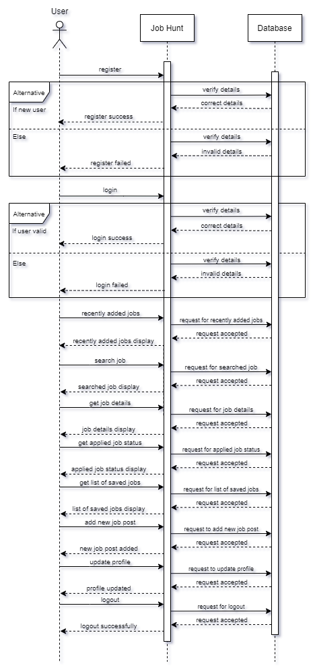

## **Admin Sequence Diagram:**

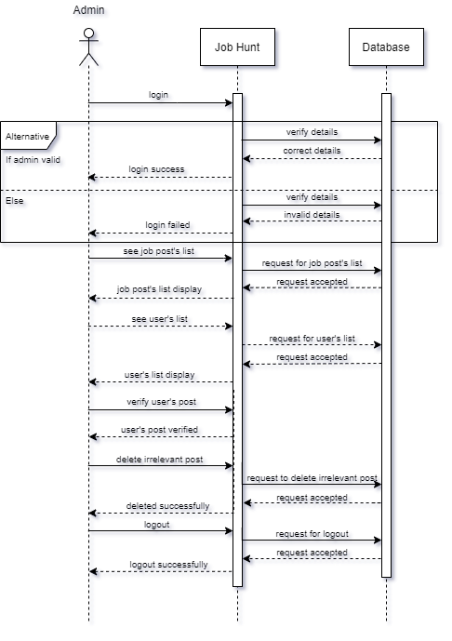

# **Activity Diagrams:**

## **User Activity Diagram:**

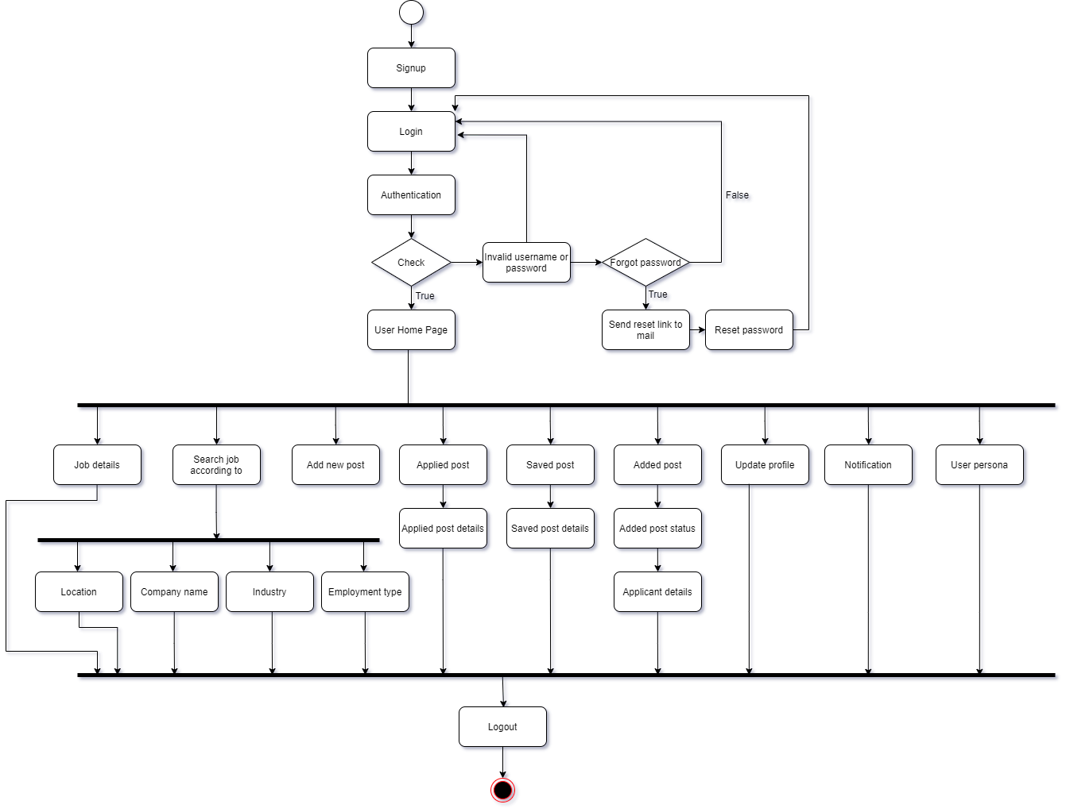

## **Admin Activity Diagram:**

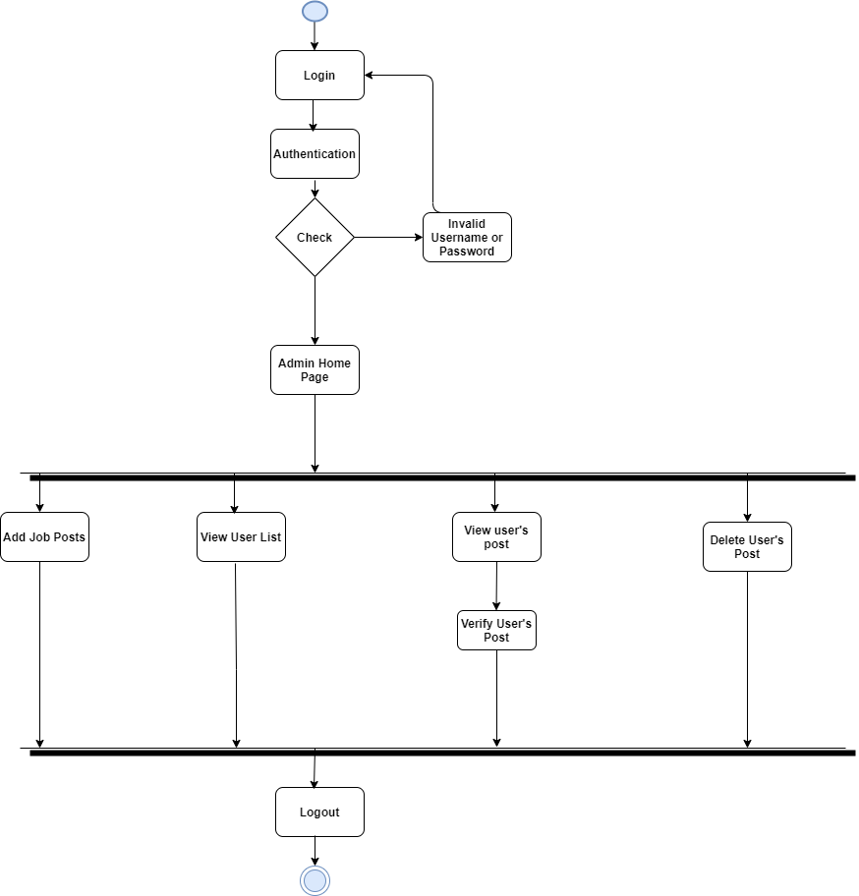

# **Use case Diagram:**

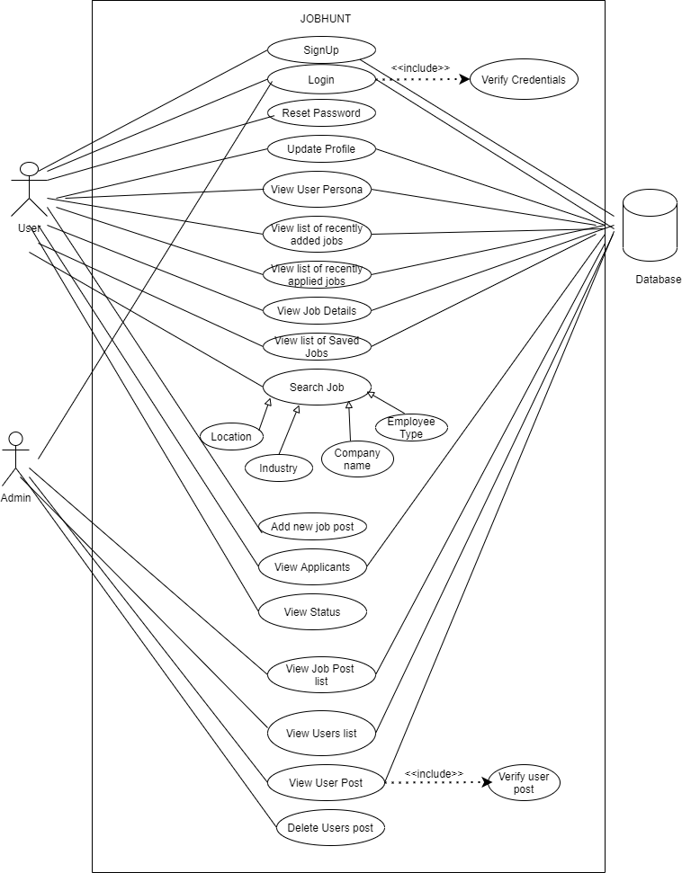

# **Class Diagram:**

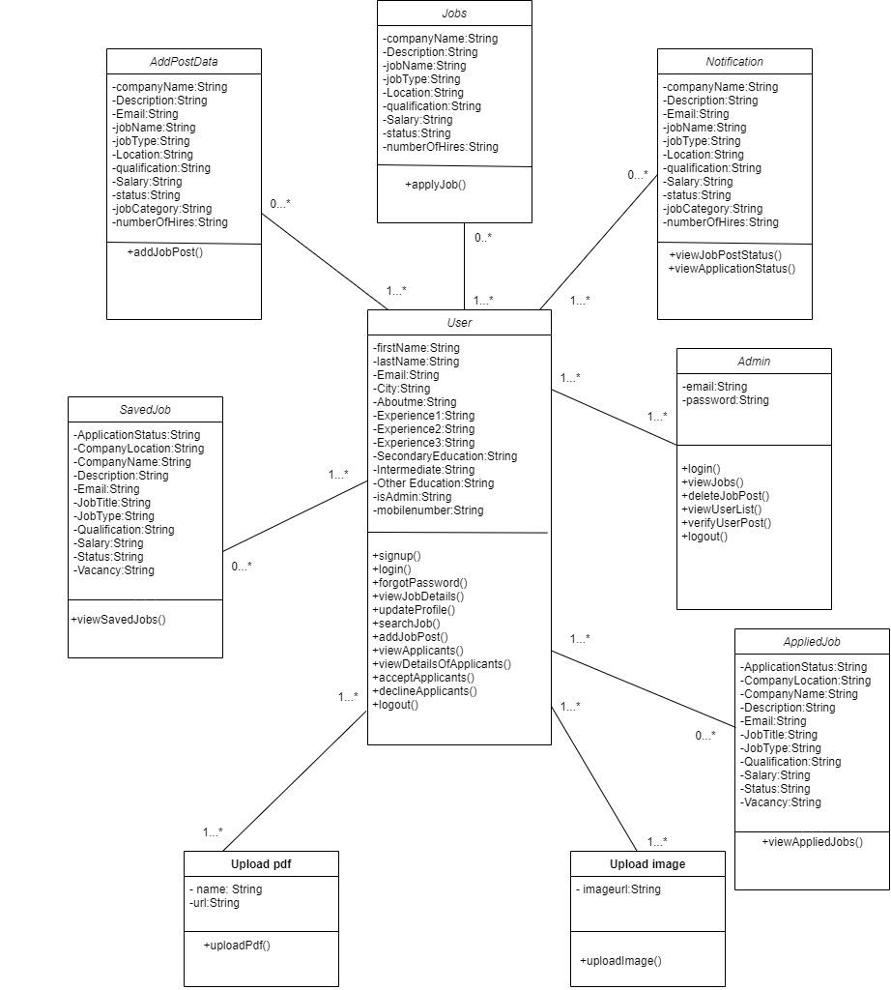

# **E-R Diagram:**

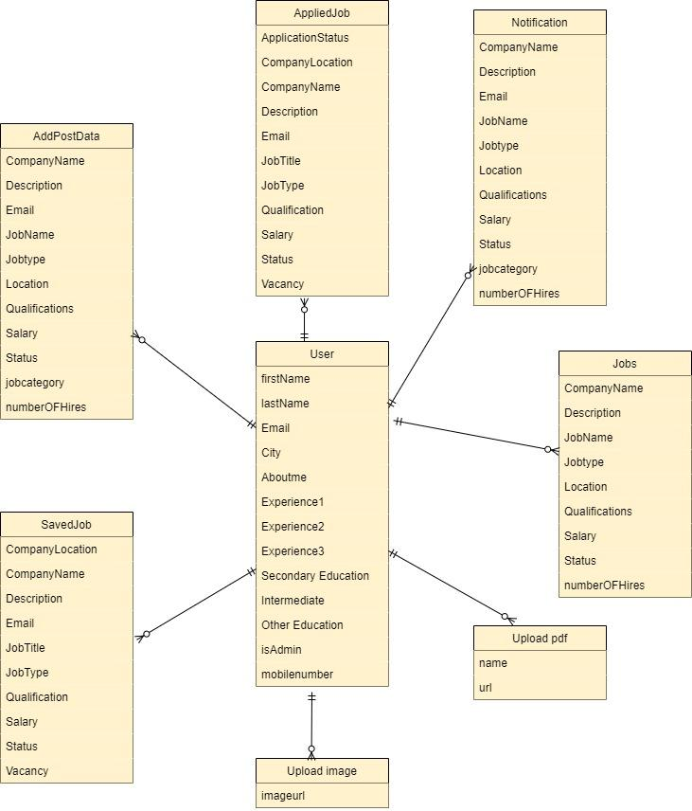

# **Fully Dressed Use Cases:**

## **User :**

**Use Case UC1 :** Apply for job

**Primary Actor :** User

**Stakeholders and interests :**

* User : Wants to apply for a job based on his/her own skills and needs.

**Preconditions :** User is registered and authenticated.

**Postconditions :**

* User applied for a job.
* User will get notification about his/her application status.
* User selected in the company for a job.

**Main Success Scenario (Basic Flow) :**

1. The user would have to register themselves in the application.
2. Once registered, the user has to login.
3. After login, the user can start to apply for a job.
4. User searches for a specific job as per his/her skills.
5. System asks the user to upload a resume to apply for the job.
6. User uploads his/her resume and applies for a job.

**Extensions :**

1a. If the user is new then he/she has to register.

2a. If a user can’t login then the user would have to update the password.

**Use Case UC2 :** Post a job

**Primary Actor :** User

**Stakeholders and interests :**

* User : Wants to post a job to recruit other people.

**Preconditions :** User is registered and authenticated.

**Postconditions :**

* The user posts a job.
* The user sets interviews with a number of applicants.
* The user recruits some people.

**Main Success Scenario (Basic Flow) :**

1. The user would have to register themselves in the application.
2. Once registered, the user has to login.
3. After login, the user wishes to post a new job.
4. System asks the user to enter details of a new job post.
5. After entering details, the user can post a new job to recruit new employees.
6. The user sets an interview with applicants.
7. The user selects a person for a job.

**Extensions :**

1a. If the user is new then he/she has to register.

2a. If the user can’t login then the user would have to update the password.

5a. If the user does not enter all details, the user will not able to post a new job.

7a. The user does not select a single person for that job post.

**Use Case UC3 :** Update profile

**Primary Actor :** User

**Stakeholders and interests :**

* User : Wants to update profile

**Preconditions :** User is registered and authenticated.

**Postconditions :**

* User profile is updated.

**Main Success Scenario (Basic Flow) :**

1. The user would have to register themselves in the application.
2. Once registered, the user has to login.
3. After login, the user wishes to update his/her profile.
4. System asks the user to enter details to update his/her profile.
5. System asks the user to submit a resume in PDF format.
6. After entering details, the user's profile is updated.

**Extensions :**

1a. If the user is new then he/she has to register.

2a. If the user can’t login then the user would have to update the password.

5a. If the user does not click on the update button then profile would noy be updated.

## 

## **Admin :**

**Use Case UC4 :** Approve a job post

**Primary Actor :** Admin

**Stakeholders and interests :**

* Admin : Wants to approve a job post which is posted by the user to recruit other people.

**Preconditions :** Admin is registered and authenticated.

**Postconditions :**

* Admin approves a job post.
* Approved job post available publicly.
* Other users can apply for that specific job.

**Main Success Scenario (Basic Flow) :**

1. The admin would have to login in the application.
2. After login, the admin wishes to see job posts which need admin’s approval.
3. System provides all jobs which need admin’s approval.
4. Admin check the post details.
5. Admin gives his/her approval.
6. Job post is available publicly.

**Extensions :**

1a. If the admin can’t login then the admin would have to update the password.

5a. If the admin does not give approval then the job post will not be published.

**Use Case UC5 :** Handle users

**Primary Actor :** Admin

**Stakeholders and interests :**

* Admin : Wants to handle users (block a user)

**Preconditions :** Admin is registered and authenticated.

**Postconditions :**

* Admin blocks a user.
* Blocked users do not use the application.

**Main Success Scenario (Basic Flow) :**

1. The admin would have to login in the application.
2. After login, the admin wishes to see the user's list.
3. System provides all users with their details.
4. Admin block users who post inappropriate content.

**Extensions :**

1a. If the admin can’t login then the admin would have to update the password.

# 

# **Application Screens**

## **User Screens:**

## 

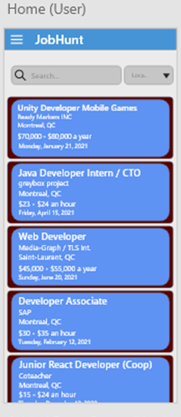 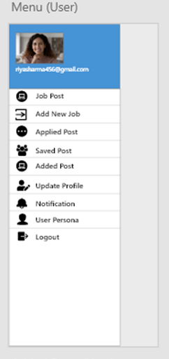

## 

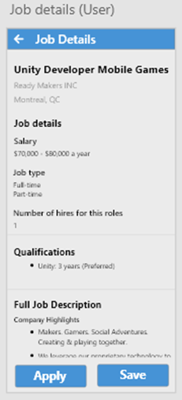 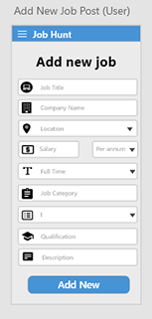

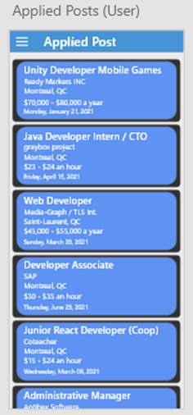 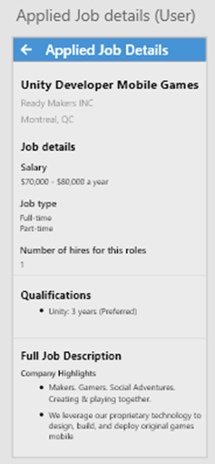

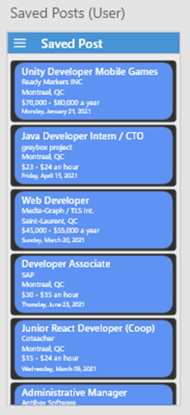 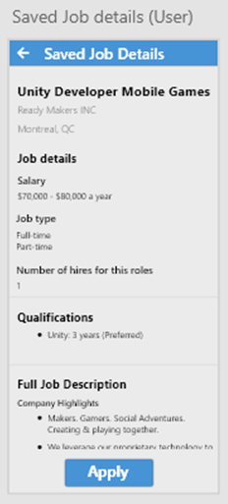

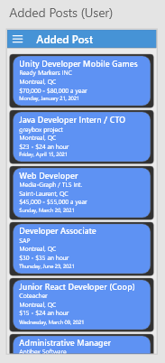 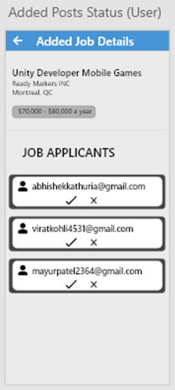

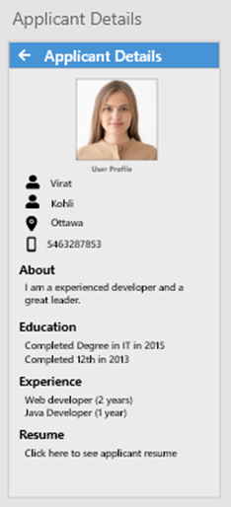 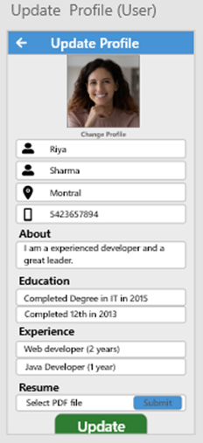

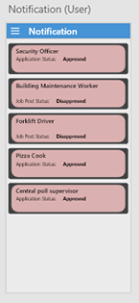 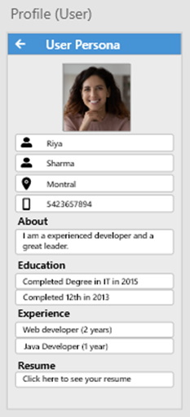

## **Admin Screens:**

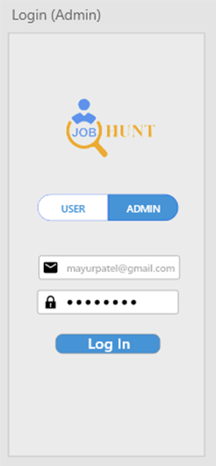 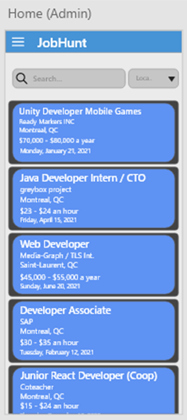

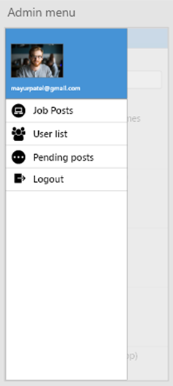 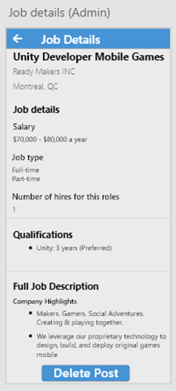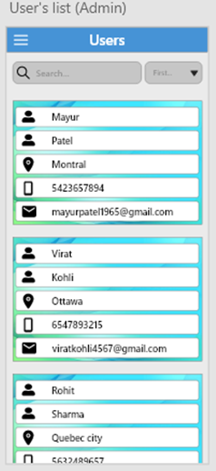 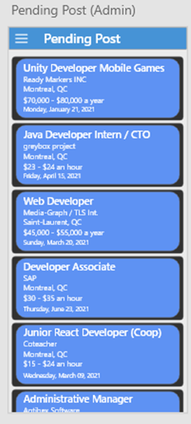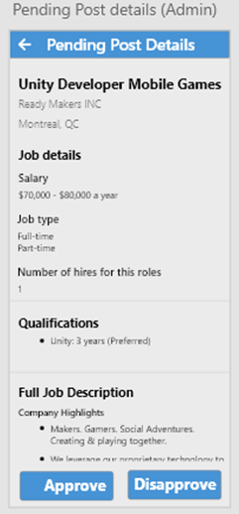

# **Prototype Flow**

## **User Screens Flow:**

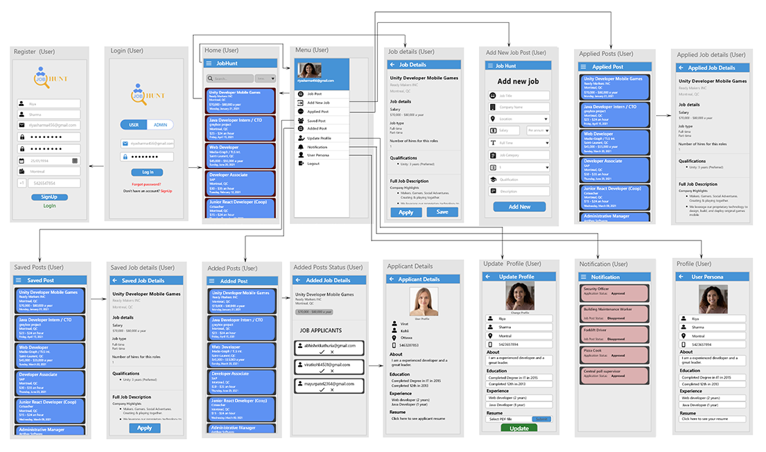

## **Admin Screens Flow:**

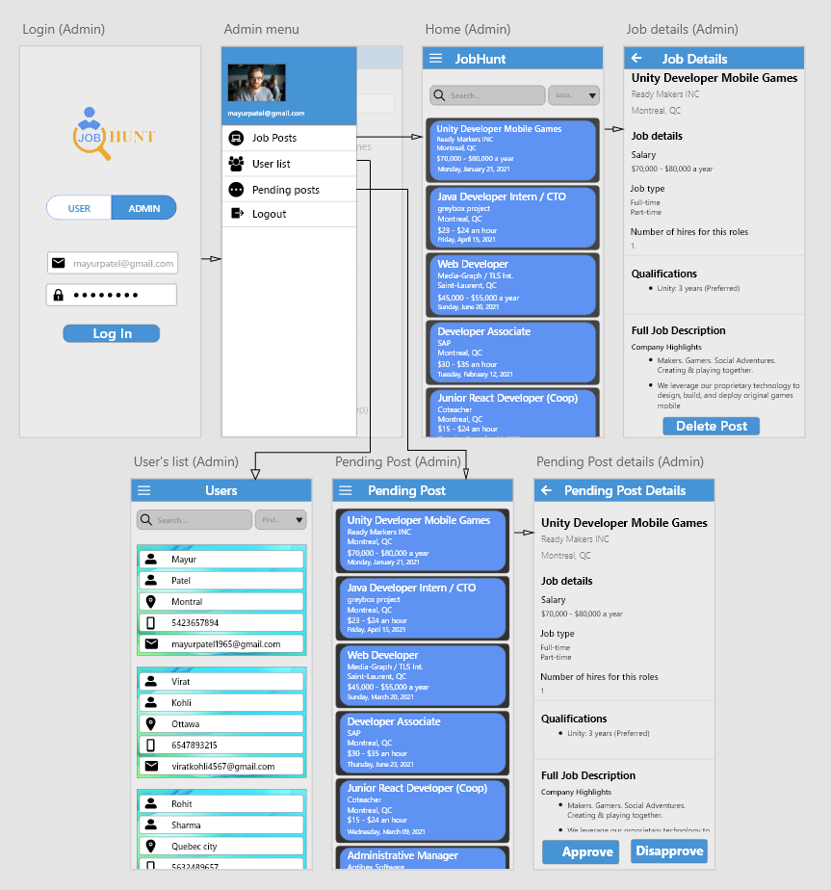

# **Test Cases**

## **User:**

|  |  |
| --- | --- |
| **Test case:1** |  |
| **User Story** | As a user I want sign up |
| **Acceptance Criteria** | 1. A user should enter all the fields in order to register. 2. The email must be in the correct format and a valid (existing) one. 3. All the information entered by the user is stored in the database. 4. The mobile number should not be less than 10. 5. After submitting the form “registration successful” is displayed and redirects to the login page. |
| **Priority** | High |
| **Test result** |  |
| **Comments** |  |

|  |  |
| --- | --- |
| **Test case:2** |  |
| **User Story** | As a user I want to login |
| **Acceptance Criteria** | 1.The user should enter the valid email address and password as per sign up.  2.Once the user successfully logged in,the user is directed to the dashboard screen. |
| **Priority** | High |
| **Test Result** |  |
| **Comments** |  |

|  |  |
| --- | --- |
| **Test Case 3:** |  |
| **User Story:** | As a user I want forgot password |
| **Acceptance Criteria:** | 1.User should enter the registered email.  2.User receives a link to the registered email to reset his/her password  3.Once the user clicks on the link user can reset the password |
| **Priority:** | low |
| **Test Result** |  |
| **Comments** |  |

|  |  |
| --- | --- |
| **Test Case 4:** |  |
| **User Story:** | As a user I want search bar |
| **Acceptance Criteria:** | When successfully logged in, it redirects to the dashboard screen where user and admin can search the jobs in the search bar. |
| **Priority:** | High |
| **Test Result** |  |
| **Comments** |  |

|  |  |
| --- | --- |
| **Test Case 5:** |  |
| **User Story:** | As a user I want to view a list of added jobs. |
| **Acceptance Criteria:** | When the user selects the “Added post” user can view all the jobs which were added by them. |
| **Priority:** | Medium |
| **Test Result** |  |
| **Comments** |  |

|  |  |
| --- | --- |
| **Test Case 6:** |  |
| **User Story:** | As a user I want to add a new job post. |
| **Acceptance Criteria:** | 1.When user selects the “Add new job” user can  add the new job by entering job title,company name,place,salary,type,job category,no of vacancies,qualification and description.  2.User should enter all the fields in order to add the job  3.Once the user enters all the fields a message “Your job post successfully sent to Admin”is displayed and redirected to the dashboard page. |
| **Priority:** | Medium |
| **Test Result** |  |
| **Comments** |  |

|  |  |
| --- | --- |
| **Test Case 7:** |  |
| **User Story:** | As a user I want job details. |
| **Acceptance Criteria:** | When the user chooses a job from the list of jobs in the dashboard page then the user should be able to view the job details. |
| **Priority:** | High |
| **Test Result** |  |
| **Comments** |  |

|  |  |
| --- | --- |
| **Test Case 8:** |  |
| **User Story:** | As a user I want the list of saved jobs. |
| **Acceptance Criteria:** | 1.When the user selects the “Saved Post”, the user can view the list of saved jobs which are saved by them.  2.User can apply for the job from the saved job list. |
| **Priority:** | High |
| **Test Result** |  |
| **Comments** |  |

|  |  |
| --- | --- |
| **Test Case 9:** |  |
| **User Story:** | As a user I want to update my details. |
| **Acceptance Criteria:** | 1.When the user selects the update Profile user can update his personal information,upload his resume.  2.when the user clicks the save button the details of the user are updated and redirected to the dashboard screen. |
| **Priority:** | Low |
| **Test Result** |  |
| **Comments** |  |

|  |  |
| --- | --- |
| **Test Case 10:** |  |
| **User Story:** | As a user I want to search job according to the location |
| **Acceptance Criteria:** | 1.In the dashboard screen, users can search for jobs according to the location.  2. When the user selects the ” location” user can view all the jobs in that particular location. |
| **Priority:** | Medium |
| **Test Result** |  |
| **Comments** |  |

|  |  |
| --- | --- |
| **Test Case 11:** |  |
| **User Story:** | As a user I want to search job according to the company name |
| **Acceptance Criteria:** | 1.In the dashboard screen, users can search the jobs according to the name of the company.  2. When the user selects the “Company Name” user can view all the jobs of that particular company. |
| **Priority:** | Medium |
| **Test Result** |  |
| **Comments** |  |

|  |  |
| --- | --- |
| **Test Case 12:** |  |
| **User Story:** | As a user I want to search job according to the industry |
| **Acceptance Criteria:** | 1.In the dashboard screen, users can search the jobs according to the Industry.  2. When the user selects the “Industry” user can view all the jobs in that particular Industry |
| **Priority:** | Medium |
| **Test Result** |  |
| **Comments** |  |

|  |  |
| --- | --- |
| **Test Case 13:** |  |
| **User Story:** | As a user I want to search job according to the Employment Type |
| **Acceptance Criteria:** | 1.In the dashboard screen, users can search for jobs according to the Employment Type.  2. When the user selects the “Employment Type” user can view all the jobs in that particular Employment Type. |
| **Priority:** | Low |
| **Test Result** |  |
| **Comments** |  |

|  |  |
| --- | --- |
| **Test Case 14:** |  |
| **User Story:** | As a user I want to search job according to Job Name |
| **Acceptance Criteria:** | 1.In the dashboard screen, the user can search the jobs according to the name of the job..  2. When the user selects the Job name, the user can view all the jobs according to the job Name. |
| **Priority:** | Medium |
| **Test Result** |  |
| **Comments** |  |

|  |  |
| --- | --- |
| Test Case 15: |  |
| User Story: | As a user I want to apply for a job. |
| Acceptance Criteria: | 1.User can apply for a job from the list of jobs.  2.Once the user clicks on the apply button “Your application is submitted” is displayed and then redirects to the dashboard screen. |
| Priority: | High |
| Test Result |  |
| Comments |  |

|  |  |
| --- | --- |
| **Test Case 16:** |  |
| **User Story:** | As a user I want to know the list of applicants who applied for a posted job. |
| **Acceptance Criteria:** | When the user selects the “Added post” user can view the list of applicants who applied for the particular job. |
| **Priority:** | High |
| **Test Result** |  |
| **Comments** |  |

|  |  |
| --- | --- |
| **Test Case 17:** |  |
| **User Story:** | As a user I want to know the details of the applicants who applied for a posted job. |
| **Acceptance Criteria:** | 1.When the user selects the “Added post”  Users can view the list of applicants with Email Ids.  2. When the user clicks on the email Id user can view the applicant details |
| **Priority:** | Medium |
| **Test Result** |  |
| **Comments** |  |

|  |  |
| --- | --- |
| **Test Case 18:** |  |
| **User Story:** | As a user I want to accept or decline the applicants who applied for a posted job. |
| **Acceptance Criteria:** | 1.When the user selects the “Added post”  Users can view the list of applicants with Email Ids.  2. When the user clicks on the email Id user can view the applicant details  3.The User can accept or decline the applicants. |
| **Priority:** | Medium |
| **Test Result** |  |
| **Comments** |  |

|  |  |
| --- | --- |
| **Test Case 19:** |  |
| **User Story:** | As a user I want to know the status of the job post. |
| **Acceptance Criteria:** | 1.When the user selects the “Notification” user can view the status of the job post whether it is approved or disapproved by the admin. |
| **Priority:** | High |
| **Test Result** |  |
| **Comments** |  |

|  |  |
| --- | --- |
| **Test Case 20:** |  |
| **User Story:** | As a user I want to know the status of the applied job. |
| **Acceptance Criteria:** | 1.When the user selects the “Notification” user can view the status of the job in which they applied for. |
| **Priority:** | High |
| **Test Result** |  |
| **Comments** |  |

## **Admin:**

|  |  |
| --- | --- |
| **Test Case 1:** |  |
| **User Story:** | As an admin I want to login |
| **Acceptance Criteria:** | 1.The admin should enter the valid email address and password.  2.Once the admin successfully logged in,the admin is directed to the dashboard screen. |
| **Priority:** | High |
| **Test Result** |  |
| **Comments** |  |

|  |  |
| --- | --- |
| **Test Case 2:** |  |
| **User Story:** | As an admin I want to view job post list |
| **Acceptance Criteria:** | 1.When successfully logged in, it redirects to the dashboard screen where the admin can search and view the jobs. |
| **Priority:** | High |
| **Test Result** |  |
| **Comments** |  |

|  |  |
| --- | --- |
| **Test Case 3:** |  |
| **User Story:** | As an admin I want to view users list |
| **Acceptance Criteria:** | When the Admin selects the “User List”admin can view the list of users. |
| **Priority:** | Medium |
| **Test Result** |  |
| **Comments** |  |

|  |  |
| --- | --- |
| **Test Case 4:** |  |
| **User Story:** | As an admin I can verify every user’s post before posted publicly |
| **Acceptance Criteria:** | 1.When the Admin selects the”Pending Post”admin can view the list of jobs posted by the user.  2.The admin can approve or disapprove the job post posted by the user. |
| **Priority:** | Low |
| **Test Result** |  |
| **Comments** |  |

|  |  |
| --- | --- |
| **Test Case 5:** |  |
| **User Story:** | As an admin I can delete any user’s post |
| **Acceptance Criteria:** | 1.When the Admin selects the”Job Post”admin can view the list of jobs posted by the user.  2. Admin can view the job details and delete the user post. |
| **Priority:** | Medium |
| **Test Result** |  |
| **Comments** |  |

# **Bibliography**

<https://www.youtube.com/results?search_query=md+jamal>

<https://firebase.google.com/docs/storage/android/start>

<https://stackoverflow.com/>

<https://developer.android.com/studio>

<https://github.com/hbb20/CountryCodePickerProject#readme>

<https://github.com/barteksc/AndroidPdfViewer#readme>

<https://www.youtube.com/watch?v=xzCsJF9WtPU&ab_channel=EasyLearn>